**Python Study Program Starter Guide**

1. Go to Path:

*\\mmnasprdfs01\Financial Planning & Budgeting\ZhuHai\Department Activity\2021 Python Study Program\learning-material*

1. Copy and Paste to folder named current to your desktop
2. 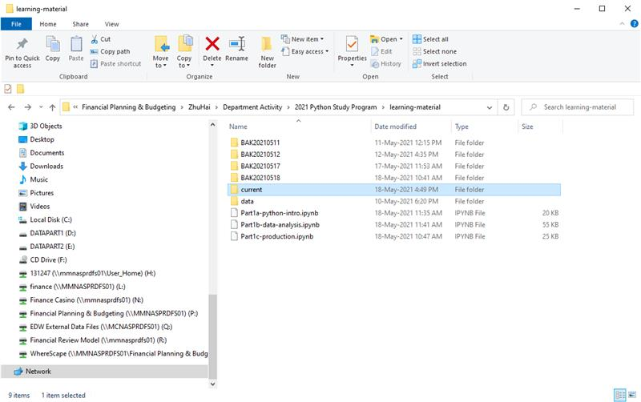
3. Run Jupyter and start learning (order: 1a, 1b, 1c)

**Jupyter Notebook User Guide**

1. Search Jupyter Notebook

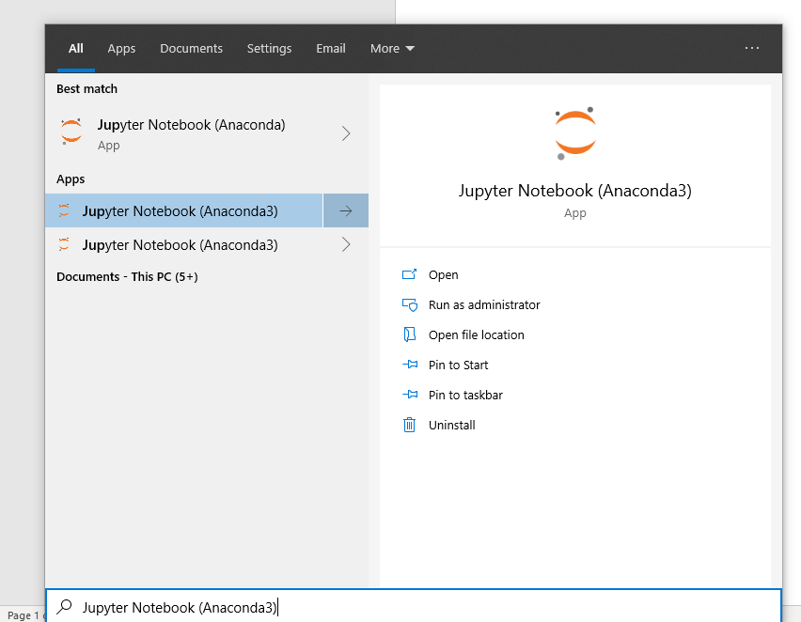

1. A command line liked program is shown if successfully start Jupyter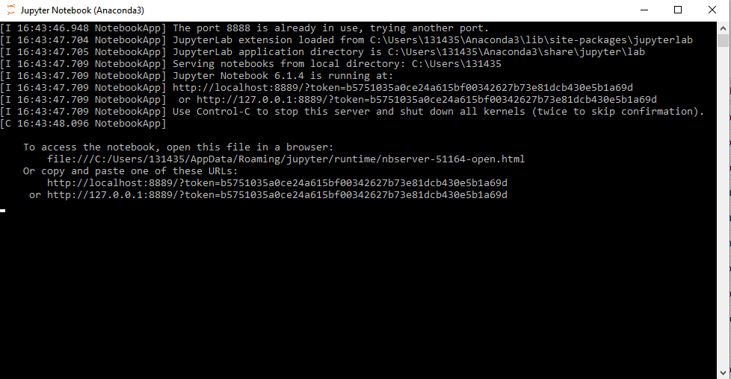
2. Your default browser should open the home page

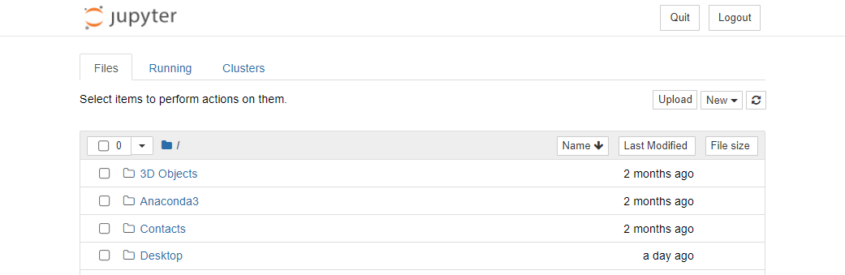

1. Go to Desktop and find current folder, you should see these files as shown below

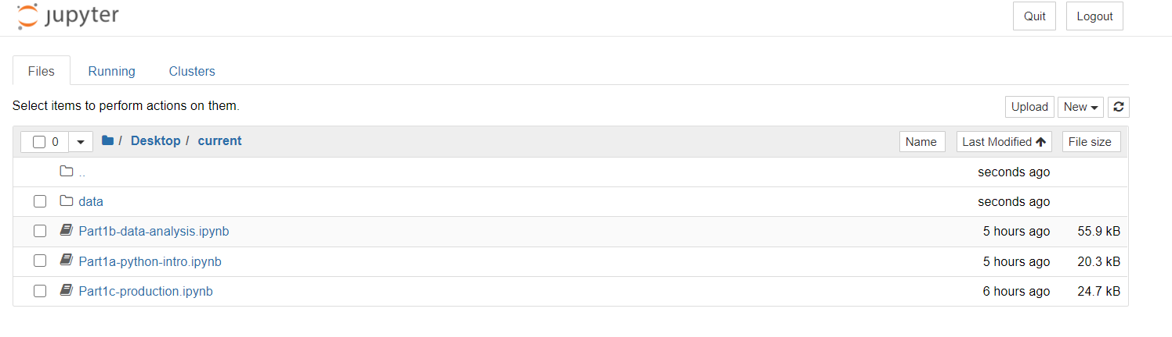

1. Click the .ipynb file and set Kernel if needed

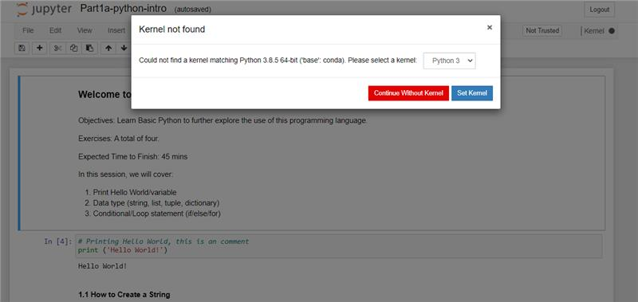

If the default kernel is not set, please set kernel ‘Python 3’ from the drop-down list

1. Run each cell by clicking  (or alternatively ctrl + enter)

For further information, please refer to:  
<https://jupyter.brynmawr.edu/services/public/dblank/Jupyter%20Notebook%20Users%20Manual.ipynb>